Use Cases –Address Book Task

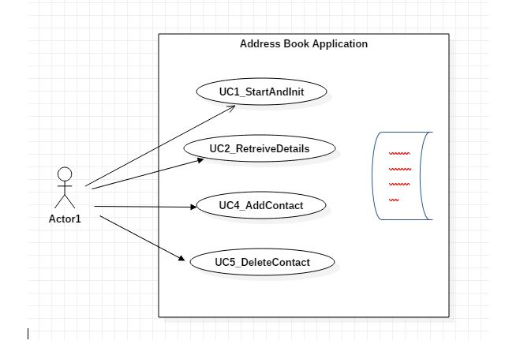

|  |  |
| --- | --- |
| Name | UC1_Start and Init |
| Version |  |
| Actors | Reece Branch Manager |
| Summary | Address book should hold name and phone numbers of contact entries |
| Pre-Conditions |  |
| Description | When the Application is loaded it should start and create initialise a list of default users in In-Memory Database |
| Acceptance Criteria | Users should be able to retrieve all contacts in an address book  Address book should hold name and phone numbers of contact entries |
| Exceptions |  |
| Result |  |

|  |  |
| --- | --- |
| Name | UC2_Retreive Contact Details |
| Version |  |
| Actors | Reece Branch Manager |
| Summary | Users should be able to retrieve all contacts in an address book |
| Pre-Conditions | At least default users should be populated in In-Memory Database |
| Description | Branch Manager should be able to re |
| Acceptance Criteria | Users should be able to retrieve all contacts in an address book  Users should be able to retrieve all contacts using all the three filters firstname,lastname ,phone or individually from the address book |
| Exceptions | NoContactDetailsFound |
| Result |  |

|  |  |
| --- | --- |
| Name | UC3_Add New Contact |
| Version |  |
| Actors | Reece Branch Manager |
| Summary |  |
| Pre-Conditions |  |
| Description | Branch Manager adds a new user into the Database |
| Acceptance Criteria | Branch Manager should be able to retrieve all contacts in an address book  Branch Manager should be able to retrieve newly added contact  If the user already exists, the details will be updated |
| Exceptions | IIlegalContactException |
| Result |  |

|  |  |
| --- | --- |
| Name | UC4_Delete Contact |
| Version |  |
| Actors | Reece Branch Manager |
| Summary |  |
| Pre-Conditions | Users list should be already populated in Memory |
| Description | Users should be able to remove an existing contact entry from an existing address book |
| Acceptance Criteria | The users deleted should no longer come up in the search |
| Exceptions | NoContactDetailsFound |
| Result |  |